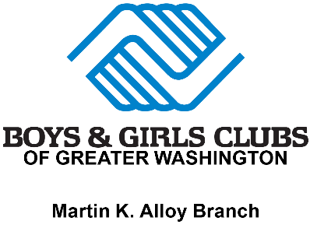

MARTIN K. ALLOY BOYS & GIRLS CLUB OF MANASSAS

WALK-IN PARTICIPATION REQUIREMENTS CHECKLIST

- Age Restrictions: Participants must be between ages 5-17.
- Immunization Records: Maybe up to 2 years old; signed by a doctor.
- Birth Certificate: Original or Certified copy accepted.
- Emergency Contacts: Full name, Full address, and Phone number.
- Physician’s Info: Name and Phone Number.
- Medication (If needed) Signed MAT Form, Allergy Action Plan, and/or Asthma Action Plan dated within the current academic school year.
- Insurance Cards: Must be up to date.
- Membership: MyClubHub requirements completed.
- SCHOOL YEAR TUITION RATES:
  - Annual Membership Fee: $50 (ages 5-12); $25 (ages 13-up); (The membership fee is waived for youth with Anthem HealthKeepers Plus or United Healthcare Community Plan or if one or both caregivers are military (Active Duty, Reserve, or Guard).
https://bgcgw.force.com/portal/s

WALK-IN MEMBERSHIP
2025-2026 SCHOOL YEAR



Boys & Girls Clubs
For Office Use Only:
Start Date: ______________

Termination Date: ________

Reason: ________________
2025-2026
SCHOOL
YEAR

Of GREATER WASHINGTON
Martin K. Alloy Boys & Girls Club of Manassas
“Funland Before & After School Program”
9501 Dean Park Lane, Manassas, VA 20110
(703) 365-2582

Application
YOUTH INFORMATION
First Name: | Last Name: |  | MI: | D.O.B.:
Address: | City: |  | Zip: | Phone #:
School Name: | Grade: |  | Age: | Sex:
CAREGIVER INFORMATION
Parent/Caregiver Name #1: |  | Parent/Caregiver Name #2:
Address: |  | Address:
Cell #: |  | Cell #:
E-mail: |  | E-mail:
Employer: |  | Employer:
Work #: |  | Work #:
Child lives with: (please check one) [ ] Mother [ ] Father [ ] Both [ ] Other
HEALTH INFORMATION
Doctor’s Name: |  | Phone #:
Medical Conditions: |  | Allergies:
Medications: |  | *A completed Medication Consent Form is required for staff to distribute medications.
EMERGENCY CONTACT & PICK UP AUTHORIZATION – Other Than Legal Caregivers
Persons authorized to pick up child in case of emergency - ALL sections MUST have complete address information.
Name: |  | Name:
Address: |  | Address:
Phone #: |  | Phone #:
ADDITIONAL INDIVIDUALS ALLOWED TO ACCESS CHILD
Only the additional individuals listed below are authorized to pick up.
Name: |  | Name:
Name: |  | Name:
Please provide a copy of legal documentation for individuals prohibited from contact with child.
EMERGENCY MEDICAL CARE AUTHORIZATION
I, _________________________, grant permission for the staff of Funland Before & After School Program and/or other Boys & Girls Clubs personnel to secure emergency medical treatment for my child while in their care. Caregiver Signature:________________________________________ Date:__________________________

PARENTAL AGREEMENTS
I ______________________________, the parent of _______________________________, give him/her permission to be transported by the staff of the Martin K. Alloy Boys & Girls Club to participate in field trips such as, but not limited to the following: swimming, bowling, putt-putt golf, skating, parks, museums, amusements parks, etc. I agree to discuss the field trip and transportation safety rules with my children while, so they will fully understand what is expected of them. I also understand that there are consequences for bad behavior and that my child’s privileges can be taken away.

Rules for Transportation and Field trips are as follows:
- Always be seated and wear a seatbelt.
- Adhere to all staff instructions.
- Remain with the assigned group and staff/chaperone.
- Refrain from vulgar/obscene language and gestures.
- Wear a Club T-shirt.

________My child will obey all rules listed in the handbook and enrollment application while on the bus or at the club.
________The child day care center agrees to notify the caregivers whenever the child becomes ill and the caregivers will arrange to have the child picked up as soon as possible if so, requested by the center.
________The caregivers authorize the child day center to obtain immediate medical care if any emergency occurs when the caregivers cannot be located.
________The caregivers agree to inform the center within 24 hours, or the next business day, after his/her child or any member of the immediate household has developed reportable communicable disease, as defined by the State Board of Health. All life-threatening diseases must be reported immediately.
________I have received a copy of the handbook and have reviewed the rules and expectations with my child.

______________________________________ ____________________________
Signature of Parent/Guardian Date

How did you hear about our program:

Please list former daycares:
PHOTO/VIDEO CONSENT
or internal promotional reasons, occasionally, we take photos of children participating in our activities.
I consent to the capturing of my child’s photo/video image to be used by Prince William County Boys & Girls Clubs.

Photo: YES (please initial) Video: YES (please initial) NO (please initial) NO (please initial)
SUNSCREEN/REPELLENT PERMISSION
I give my child permission to have sunscreen and or/bug repellent applied on any given day during our program. I understand that they will be using SPF-15 or higher.

Signature of Parent/Guardian Date
OFFICE USE ONLY – IDENTITY VERIFICATION Staff Initials:
Place of Birth | Date of Birth
Birth Certificate Number | Date Issued
Other Form of Proof
Proof of the child’s identity and age may include a certified copy of the child’s birth certificate, birth registration card, notification of birth (hospital, physician or midwife record), passport, copy of the placement agreement or other proof the child’s identity from a child placing agency, record from a public school in Virginia, or certification by a principal or his designee of a public school in the U.S. that a certified copy of the child’s birth record was previously presented. Viewing the child’s proof of identity is not necessary when the child attends a public in Virginia and the center assumes responsibility for the child directly from the (i.e. after program) or the center transfers responsibility of the child directly to the (i.e. before program). While programs are not required to keep the proof of the child’s identity, documentation of viewing this information must be maintained for each child.

GREAT FUTURES START HERE.

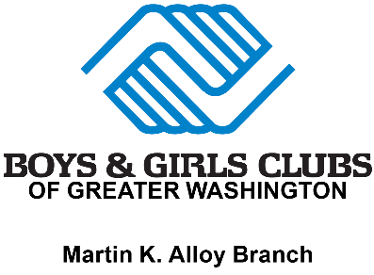

Special Needs Identification Sheet

Attention Caregivers,

To best support the success and wellbeing of all our youth, we kindly ask you to provide information regarding your child's documented special needs via an Individualized Education Program (IEP) or 504 Plan. We appreciate the information you provide as it allows us to learn more about what is necessary to meet your child’s needs and support their success.

Does your child have a documented special need via an Individualized Education Program (IEP) or 504 Plan?

(Please check one.) [ ] Yes [ ] No If yes, please provide details:

Disability/Disabilities Identified:
__________________________________________________________________________

__________________________________________________________________________

__________________________________________________________________________

__________________________________________________________________________

Accommodation(s) Identified:
__________________________________________________________________________

__________________________________________________________________________

__________________________________________________________________________

__________________________________________________________________________
*Please attach a copy of the child's IEP or 504 Plan if available.

I acknowledge that the special needs information provided is accurate to the best of my knowledge.

Child’s Name:________________________________________ Age:__________________

Caregiver Signature: __________________________________ Date: _________________

