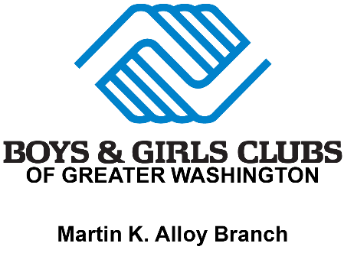

Teen Program Overview:
diplomas2Degrees (d2D) (Education): a college readiness program, guides Club members as they work toward high school graduation and prepare for post-secondary education and career success. d2D helps teens develop both short- and long-term goals, while familiarizing them post-secondary education through experiences like college tours. It also assists youth in securing financial aid and fosters supportive relationships with adults who can provide support throughout the college experience.

Youth of the Year (Leadership and Service): is our signature effort to foster a new generation of leaders, fully prepared to live and lead in a diverse, global and integrated world economy.
In the 21st-century world and workplace, leadership skills such as communication, goal-setting and teamwork are essential for everyone - especially young people preparing to meet the challenges of adolescence and adulthood. With a grassroots beginning in 1947, Youth of the Year has evolved into a comprehensive leadership development program, which includes:
SMART Girls (Health and Wellness): is a small-group health, fitness, prevention/education and self-esteem enhancement program designed to meet the developmental needs of girls in three age groups, spanning ages 8 to 18. Through dynamic sessions, participatory activities, field trips and mentoring opportunities with adult women, Club girls explore their own and societal attitudes and values as they build skills for eating right, staying physically fit, getting good health care and developing positive relationships with peers and adults.
Passport to Manhood (Health and Wellness): represents a targeted effort to engage young boys in discussions and activities that reinforce character, leadership and positive behavior. Each participant receives a “passport” to underscore the notion that he is on a personal journey of maturation and growth. Each of the program’s 14 sessions use interactive activities to focus on a specific aspect of character and manhood. It also includes a service project where boys learn the importance of giving back to the community.

Power Hour (Education): Making Minutes Count helps Club members ages 6-18 achieve academic success by providing homework help, tutoring and high-yield learning activities and encouraging members to become self-directed learners. Designed specifically to help kids and teens with homework, this program is available after school at Clubs. Dedicated youth development professionals and volunteers supervise each session and help youth members complete their assignments for the day. When they finish their work, they may choose to participate in a variety of other engaging and educational activities to develop their skills even further. Power Hour is a great opportunity for kids and teens to get their homework completed in a quiet place with support from trained, caring staff at a Boys & Girls Club.
Keystone (Leadership and Service): Clubs provide leadership development opportunities for young people ages 14 to 18. Youth participate in activities in three focus areas: academic success, career preparation and community service. With the guidance of an adult advisor, Keystone Clubs aim to have a positive impact on members, the Club and community. BGCA hosts an annual National Keystone Conference for Boys & Girls Club teens that brings together members from all across the globe. Throughout the conference, Keystone members engage and socialize with peers, explore relevant issues, and develop skills to support and enhance efforts in their local Boys & Girls Clubs and communities.
Career Launch (Education): encourages Club members ages 13 to 18 to assess their skills and interests, explore careers, make sound educational decisions and prepare to join our nation's work force. Club staff or volunteers help teens build their job-search skills and job readiness by using the Career Launch Facilitator Guide and working with teens individually or in small groups. The Career Launch page provides Club teens, staff and volunteers with online career exploration, college and job search information and interactive activities. Mentoring, job shadowing and training opportunities round out the program.

