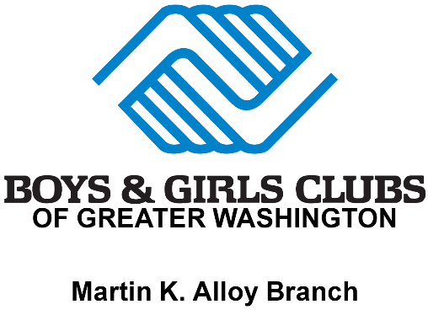

www.bgcgw.org

2023-2024 SCHOOL YEAR CHECKLIST

DO YOU HAVE ALL ITEMS LISTED BELOW?

- Copy of the physical form (no more than two years old) and immunization records signed by a physician

- Birth Certificate (We need to see the original or a certified copy)

- (2) Emergency Contacts (Name, full addresses and phone numbers)

- Doctor’s name and phone number (If the child is a military dependent, provide the name of the hospital and phone number)

- Insurance Information

- Registration / Membership / Week’s Payment

- All paperwork filled out completely

**All these items are required by the Virginia Department of Education. No one will be registered without submitting all of the above required documents at the time of registration.

Ages 5-16
2023 – 2024 SCHOOL YEAR

Boys & Girls Clubs of Greater Washington
2023-2024
SCHOOL
YEAR
For Office Use Only: Start Date: Termination Date: Reason:
Martin K. Alloy Boys & Girls Club of Manassas
Funland Before and After Care Program
9501 Dean Park Lane, Manassas, VA 20110
https://www.bgcgw.org
703-365-2582

Application
YOUTH INFORMATION
First Name | Last Name |  |  | MI |  | DOB
Address | City |  |  | Zip |  | Phone Number
School | Grade |  |  | Age |  | Sex
 |  | FAMILY INFORMATION
Mother Name: |  |  | Father Name:
Address: |  |  | Address:
E-mail |  |  | E-mail
Employer |  |  | Employer
Work Number |  |  | Work Number
Cell Number |  |  | Cell Number
Child live with: (please check one) [ ] Mother [ ] Father [ ] Both [ ] Other
HEALTH INFORMATION
Doctors Name |  |  | Phone Number
Health Problems (if any) |  |  | Allergies
Medications (if any) |  |  | **Any Medications to be administered at our facility must be  accompanied by a completed Medication Consent Form**
EMERGENCY CONTACT & PICK UP AUTHORIZATION – Other than Parents
Persons authorized to pick up child in case of emergency - ALL sections MUST have complete address information
Name: |  |  | Name:
Address |  |  | Address
Phone Number |  |  | Phone Number
OTHER PERSONS ALLOWED TO PICK UP CHILD
Any person not listed will NOT be able to pick up children from our facility
Name: |  |  | Name:
Name: |  |  | Name:
Is there anyone legally NOT allowed to pick up your child? If so, we must have a copy of the legal
paperwork on file.
EMERGENCY MEDICAL CARE AUTHORIZATION
I, hereby authorize Funland Before & After School program staff and/or other Boys & Girls Club staff to obtain emergency medical care for my child while under their care. I also have received, read, and understand the Fun Land brochure outlining the rules and regulations of the Day Care, which my child and I will abide by.

Parent Signature Date

PARENTAL AGREEMENTS
I ______________________________, the parent of _______________________________ , give him/her permission to be transported by the staff of the Martin K. Alloy Boys & Girls Club to participate in field trips such as, but not limited to the following: swimming, bowling, putt-putt golf, skating, parks, museums, amusements parks, etc. I agree to discuss the fieldtrip and transportation safety rules with my children while, so they will fully understand what is expected of them. I also understand that there are consequences for bad behavior and that my child’s privileges can be taken away.

Rules for transportation and field-trips are as follows:
must be seated and wear a seatbelt at all times
must adhere to all staff instructions
must remain with assigned group and staff/chaperone
must refrain from vulgar/obscene language and gestures
must wear summer camp t-shirt

________My child will obey all rules listed in the handbook and membership application while on the bus or at the club.

________The child day care center agrees to notify the parent(s)/guardian(s) whenever the child becomes ill and the parent(s)/guardian(s) will arrange to have the child picked up as soon as possible if so requested by the center.

________The parent(s)/guardian(s) authorize the child day center to obtain immediate medical care if any emergency occurs when the parent(s)/guardian(s) cannot be located.

________The parent(s)/guardian(s) agree to inform the center within 24 hours, or the next business day, after his/her child or any member of the immediate household has developed reportable communicate disease, as defined by the State Board of Health. All life threatening diseases which must be reported immediately.

________I have received a copy of the handbook and have reviewed the rules and expectations with my child.

______________________________________ ____________________________
Signature of Parent/Guardian Date

PICTURE/VIDEO AUTHORIZATION
From time to time pictures are taken of the children attending our activities and on occasion are used in-house for promotional purposes.
I give permission for my child(ren)’s picture to be taken and if selected, to be used by the Prince William Boys & Girls Clubs.

Photo: YES (please initial) Video: YES (please initial) NO (please initial) NO (please initial)
SUNSCREEN/REPELLENT PERMISSION
I give my child permission to have sunscreen and or/bug repellent applied on any given day during our program. I understand that they will be using SPF-15 or higher.

Signature of Parent/Guardian Date
OFFICE USE ONLY – IDENTITY VERIFICATION Staff Initials:
Place of Birth | Date of Birth
Birth Certificate Number | Date Issued
Other Form of Proof
Proof of the child’s identity and age may include a certified copy of the child’s birth certificate, birth registration card, notification of birth (hospital, physician or midwife record), passport, copy of the placement agreement or other proof the child’s identity from a child placing agency, record from a public school in Virginia, or certification by a principal or his designee of a public school in the U.S. that a certified copy of the child’s birth record was previously presented. Viewing the child’s proof of identity is not necessary when the child attends a public school in Virginia and the center assumes responsibility for the child directly from the school (i.e. after school program) or the center transfers responsibility of the child directly to the school (i.e. before program). While programs are not required to keep the proof of the child’s identity, documentation of viewing this information must be maintained for each child.

Infection Control Policy

It is inevitable that children will get sick, no matter where they are. As children begin to have contact with the world around them, they come into contact with viruses and bacteria that are foreign to their bodies. This is the way they build up their immunities. We cannot shield a child completely; however we do want to protect a child from an unusually high exposure to germs all at once.
In the Club setting, children are in contact with many other children. It is in this situation that the illness of one child can spread rapidly through the rest of the group and the staff as well if stringent measures to prevent this spread are not taken.
For this reason, the staff at the center will take constant precautions to prevent the spread of disease. Many common childhood diseases are contagious. They are caused by germs which may be spread through coughs, sneezes, and runny noses. Other diseases are spread through direct contact. Careful hand washing by staff and children can eliminate approximately 75% of the risk of spreading these illnesses. Other precautions include separating sick children from those who are well and working to maintain sanitary conditions throughout the center.
You, the parents, can help us in our effort to keep your children healthy. We ask for your cooperation in the following ways:
- If your child has been exposed to any diseases listed on the accompanying chart, we ask that you notify us of the exposure within the 24 hours or by the next business day.
- If your child shows any of the following symptoms you will be called and asked to come immediately. If your child has any of the following symptoms at home, we ask that you keep them out of day care until the symptoms are gone or a physician says it’s ok to return.
The symptoms include:
- A fever greater than 100 F
- Severe coughing-child gets red or blue in the face
- High-pitched croupy or whooping sounds after coughing
- Difficult or rapid breathing
- Yellowish skin or eyes
- Pinkeye – tears, redness of eye lining, followed by swelling and discharge
- Unusual spots or rashes
- Sore throat or trouble swallowing
- Infected skin patches
- Crusty, bright yellow, dry, or gummy areas of skin- accompanied by fever
- Unusually dark, tea colored urine-especially with a fever
- Grey or white stool
- Stiff neck
- Vomiting
- Severe itching of body or scalp or scratching of the scalp

It is imperative that we all work together to keep all of the children who attend the center as healthy and happy as possible. We thank you for your cooperation.

Infectious Control Policy Agreement

I have read and understand the infection control policies, and I agree to abide by them for the protection of my child as well as the other children and staff members at the Boys & Girls Club.

Parent/Guardian Name Date

CODE OF CONDUCT

- Play fairly and be honest.

- Hand washing upon arrival is mandatory.

- Be respectful of Boys & Girls Club Staff.

- Say only good things about others.

- Resolve disagreements in a positive way.

- Be respectful of other members and their property.

- Take care of your Boys & Girls Club facility and equipment.

- Avoid the use of improper language.

- Remove hats / caps before entering the building.

- Applaud the efforts of others.

- Run outside and in the gym only.

- Stay with your assigned group at all times.

- Listen when staff is talking to you.

- Dress appropriately at all times.

- Smoking, drugs, alcohol and weapons are prohibited.

- Chewing gum is not allowed. Eat and drink in designated areas only.

- While on the B&G Club’s bus/van you must be seated and have a seatbelt on at all times.

- Cell phones are not allowed during daycare hours.

- After 3 incidents you are suspended from daycare (there are offenses that can require immediate suspension – (at the discretion of the Daycare Director and Branch Director)

- Toys, games, etc. need to stay home. We are not responsible for lost, stolen, or broken items.

- Two week notice is required to remove your child from the summer program.

If a child is not picked up by 6 PM, there is a late fee. This late fee must be paid by the next business day. There is no Stay Late Policy for the daycare program. The child must be signed out.

I agree to the following rules. I know that if I don’t follow the rules there will be consequences for my actions.

Member’s signature Date

I acknowledge that I have read and gone over the Parent Handbook and I understand what is expected of my child(ren).

Parent’s signature Date

Before and After Care Contract

I want my child_________________________________ to attend:

** (Please check one) **

- Before & After Care: 6:00 am to 6:00 pm Monday—Friday at the cost of $115/week per child. I understand that B/A Care will open on teacher workdays (TWD) and some snow days. I also understand that my child will be permitted to stay at the club for delayed openings and early dismissals at no extra cost to me. I also understand that my child must bring a lunch and a drink on those days.

- Before Care Only: 6:00 am to 9:00 pm Monday—Friday at the cost of $65/week per child. I understand that my child will be permitted to stay after 9 A.M. for delayed openings. I understand that…I, the parent, am responsible for the transportation of my child after school, and that the club is NOT responsible to pick my child up for early dismissals. If there is a teacher work day or snow day, etc., where the children are out of school all day, I understand that my child is permitted to attend at the additional cost of $30/day. I also understand that my child must bring a lunch and a drink on those days.

- After Care Only: 3:00 pm to 6:00 pm Monday—Friday at the cost of $80/week per child. I understand that my child will be picked up by the club for early dismissals due to snow, etc. I understand that I am solely responsible for getting my child to school. I understand that if there is a teacher workday or snow day, etc., I can send my child for the full day for an additional of $30/day. I also understand that my child must bring a lunch and drink on those days.

_______________________________ ________________
Parent Signature Date

*Once I have decided on either morning or after care, I understand that I cannot switch back and forth due to space availability.

___________ Initials

Parent Payment Agreement

Just a Reminder:

ABSOLUTELY NO CASH, CHECK OR MONEY ORDER PAYMENTS! PLEASE PLAN ACCORDINGLY…NO REFUNDS. Payments are made online. Please register and pay tuition via https://bgcgw.force.com/portal/s.

Payments are due the Friday before the scheduled week of attendance. If the payment is not received by Friday @ 5:00 pm…A $10 LATE FEE WILL BE APPLIED TO ALL PAYMENTS RECEIVED ON MONDAY!! NO EXCEPTIONS!

Thank you in advance for your cooperation.

Tiffanie Toliver Jadzia Ezouah Ms. Debbie Colston
Daycare Director Asst. Daycare Director Branch Director

____________________________________________________________________________________________

I have read and understand the policies concerning payment procedures and agree to abide by all payment policies of the Martin K. Alloy Boys & Girls Club.

Child’s Name Date

Parent/Guardian Name Parent/Guardian Signature

Transportation Authorization

2023-2024 School Year

I ______________________________________, give the Boys & Girls Club (Funland Before &
Parent’s Name

After School Care Program authorization to transport my child/children,

Child/Children’s name

to and from .

Child’s School name

Parent Signature Date

Director Signature Date

Closed for Federal Holiday’s 2023 Schedule

(**These days are NOT pro-rated)

Sunday, January 1st, 2023 New Year’s Day
(Observed on Monday, January 2)
Monday, January 16th Dr. Martin Luther King, Jr. Day
Monday, February 20th President’s Day
Monday, May 29th Memorial Day
Monday, June 19th Juneteenth
Tuesday, July 4th Independence Day
Monday, September 4th Labor Day
Monday, October 9th Indigenous Peoples’ Day
Friday, November 10th Veterans’ Day
Thursday, November 23rd Thanksgiving Day
Friday, November 24th Day after Thanksgiving Day
Monday, December 25th Christmas

Closed for BGCGW Trainings 2023 Schedule

(**These days are pro-rated)

August — TBD
Friday, September 8
Friday, December 1

*We may close on days not listed above, but this will be communicated in advance.

REQUIRED FOR OUR PARENTS

Sign up for important 2023-2024 School Year updates from TEAM ALLOY!

Get information for Martin K. Alloy Boys & Girls Club right on your phone—not on handouts
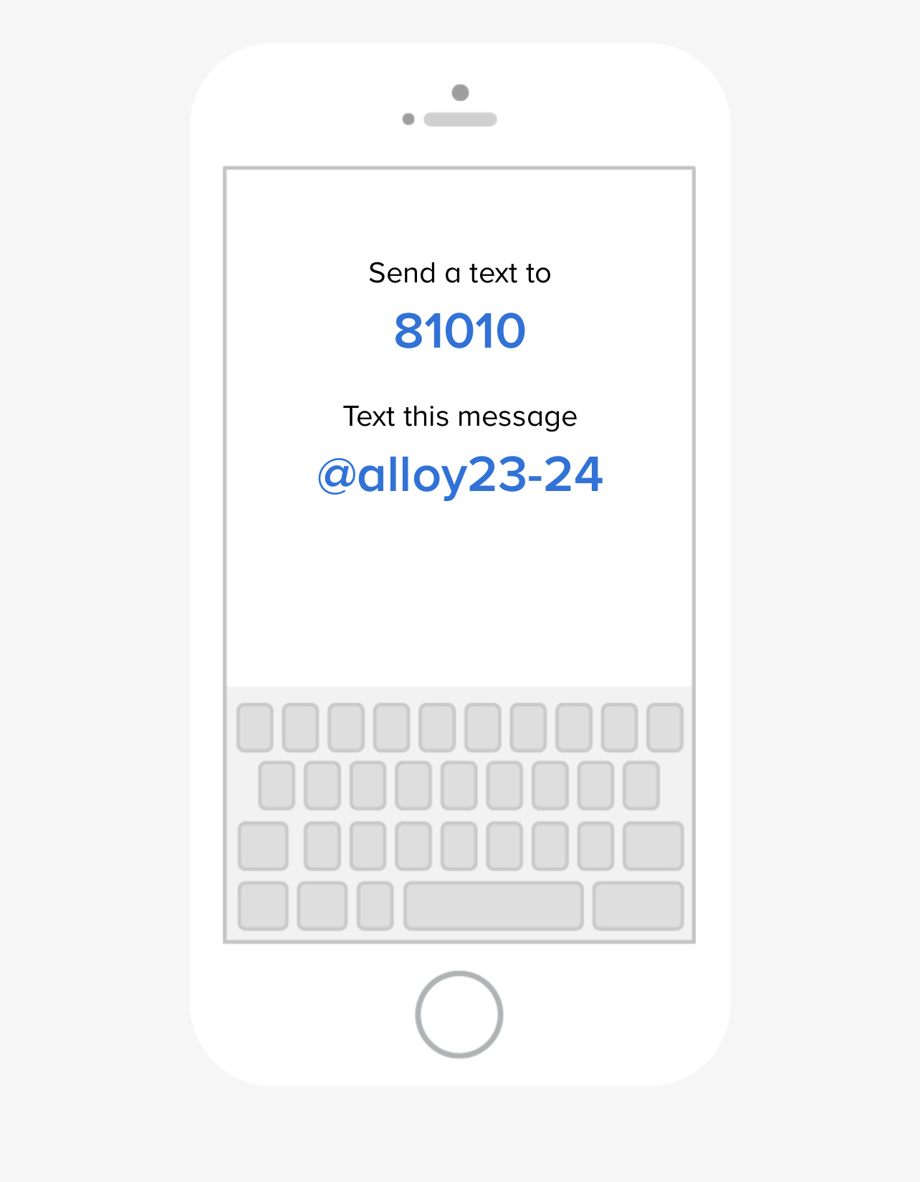

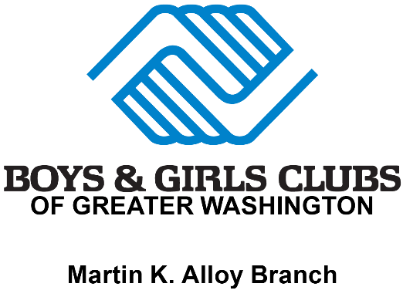

Phone Policy Addendum for Boys & Girls Clubs Members

**NO CELL PHONES or ELECTRONICS DURING PROGRAM HOURS**
- It has been brought to our attention that some members are displaying inappropriate material on their phones in the Clubs. Effective immediately upon the parent’s signature, the following will go into effect.
- Any member that is found to display or show to other members inappropriate material, will lose their ability to have a phone at the Club. This is a zero-tolerance policy.
- The phone will be confiscated and held until a parent or designated guardian arrives for pick up. The phone will be turned over to the parent and subsequently not allowed back in the Club for the remainder of the summer program. No exceptions to this rule.
- All communication with the Club member by parents or family members will be through the Club’s landline once the privileges are revoked.
- Phones are not allowed to be in use when programs that require members to pay attention are being conducted.

_______________________________ ______________________________
Parent’s Signature & Date Member’s signature & Date

Discipline/Corrective Behavior

On the occasion that a child/children’s behavior is inappropriate, or a conflict arises, the following progression of discipline will be used to modify the inappropriate behavior.
  - Removal from activity/timeout.
    - This is used for a small infraction of a Club rule (i.e. not listening, not showing proper respect to staff or Club members, or being a disruption).

The following steps will result in a notification going home that must be signed by a parent/guardian and then returned to the Club staff member who issued it.
- 1st notice
Suspension of privileges of participation in activities.
- 2nd notice (in a 4-week period)
Staff/Club member conference to review their behavior and outline corrective actions for the Club member.
- 3rd notice (in a 4-week period)
Staff/Club Member & Parent conference to review their behavior and work together to modify the Club members’ behavior.
    - This will also result in a suspension from the Club. It shall be up to the discretion of the Club director as to the length of the suspension.

- Any type of physical fighting/violence, threats, bringing of weapons and drugs will result in an automatic suspension from the Club, and possibly the program. The authorities will be notified for severe violations (e.g. weapons, drugs)

- Depending on the infraction of rules or behavior of the Club member, the Director may upon their discretion automatically jump to any level of discipline. Every effort will be made to minimize the need for using discipline, however when an issue does arise, it is our goal to quickly get the child/children back on track into Club activities.

Parents, please speak with your child(ren) about his/her behavior while attending the Boys & Girls Club. Thank you!!

__________________________ ____________________
Club Member’s Name(s) Parent Name and Date

